**Program No: 06**

**Name: Sanio Luke Sebastian**

**Roll No: 35**

**Batch: B**

**Date: 10-06-2022**

**Aim:** Implementation of triggers

**Questions:**

1. Create a Trigger for employee table it will update another table salary while updating values.
2. Create a Trigger for employe table it will update another table personal_updations while updating values.

**Procedure & Outputs:**

create database lab_trigger;

use lab_trigger;

1. **Question 01-**

CREATE TABLE student ( stud_id int(4) NOT NULL PRIMARY KEY auto_increment, name varchar(30), subject1 int(2), subject2 int(2), subject3 int(2), total int(3), per int(3));

CREATE TRIGGER mark

BEFORE INSERT ON student FOR EACH ROW

SET new.total=new.subject1+new.subject2+new.subject3, new.per= new.total / 300 * 100;

select * from student;

insert into student values (null,"Goblin",91, 89,82,0,0);

insert into student values (null,"Denvin",76, 91,67,0,0);

insert into student values (null,"Finny",78, 64,79,0,0);

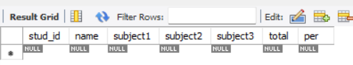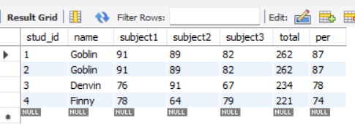

1. **Question 02-**

CREATE TABLE marks ( stud_name VARCHAR(20), total_marks int(3));

CREATE TRIGGER mark_trigger

AFTER INSERT ON student FOR EACH ROW

INSERT INTO marks(stud_name,total_marks) VALUES(new.name,new.total);

INSERT INTO student (stud_id, name, subject1, subject2, subject3) values(null,'Avil',78, 65, 91),(null,'Godwin',67, 86, 55),(null,'Henry',81, 96, 63);

SELECT *FROM marks;

